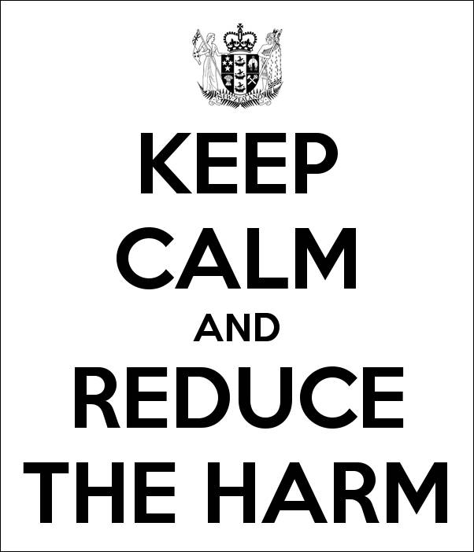

*‘Making the most out of our new liquor laws’*

***This is a FREE forum. Please note that registration is compulsory to attend this event.***

**When: Thursday 23rd May 2013**, **9.30am – 3:30pm** (Registration including tea and coffee from 9:00am)

**Where: Fickling Convention Centre**, **546 Mt Albert Road, Three Kings, Auckland**

Please complete a separate form for each person registering:

Name: ­­­­­­­­­­­­­­­­­­­­­­­­­­­­­­­­_______________________________________________________________

Organisation: __________________________________________________________

Title/Occupation: _______________________________________________________

Postal Address: _________________________________________________________

_____________________________________________________________________

Telephone: ____________________________________________________________

Email Address: _________________________________________________________

Morning tea, lunch, afternoon tea and refreshments will be provided during the day.

If you have any special dietary requirements please detail here: _____________________

**Please RSVP to Suzanne Lopes, Alcohol Healthwatch by Email:** [**suzanne@ahw.org.nz**](mailto:suzanne@ahw.org.nz),

**Ph (09) 520 7036, Fax: (09) 520 7175 or Post, PO Box 99407, Newmarket, Auckland 1149, by noon on Friday 17th May, 2013.**

***Please note****: Should venue capacity be reached Alcohol Healthwatch reserves the right to limit registrations.*

