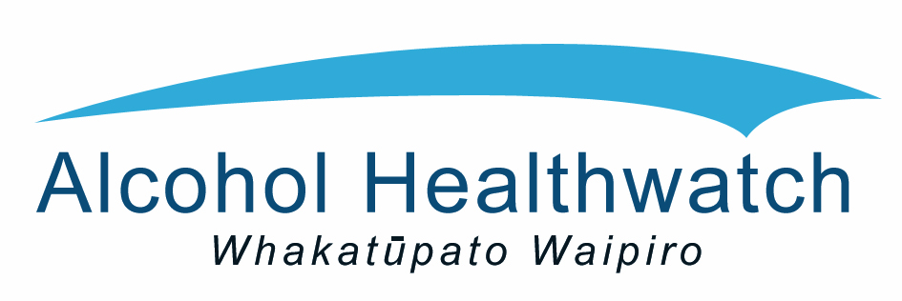
On behalf of the Executive Planning Group

Invites you to

ACTION ON ALCOHOL – ENHANCING OUR EFFORTS
Auckland Alcohol Planning Forum

Tuesday 15th September 2015

9:30am to 4:15pm
Waipuna Conference Centre, Mount Wellington
58 Waipuna Road, Mt. Wellington, Auckland

About the Forum
The Action on Alcohol Plan aims to reduce alcohol-related harm and inequalities in Auckland.
At previous regional forums the sector called for: greater collaboration and co-ordination; a strategic framework to support cohesiveness and an inter-sectoral approach; to build on the work already underway; and to build capacity and grow resources.
In response to these needs an Executive Planning Group was established. They have worked collaboratively to develop and begin implementation of the Action on Alcohol Plan.
We’d now like to share the Plan with the wider sector in order to:

Increase awareness and understanding of the Plan, and build support for its effective implementation;

To identify opportunities to enhance the implementation of the Plan through – collaboration, co-ordination and otherwise adding value;

To gain sector input on priorities for next 18 months.

Who should attend the Forum?
We invite people with an interest in reducing alcohol-related harm in Auckland to join the Forum. This includes those from statutory agencies, policy and planning, local government, community organisations, addictions and treatment, health and social services such as Health Promotion, Injury Prevention and Violence Prevention.

Registration
Please fill in and submit the registration either online http://tinyurl.com/qdom66g or email the attached form back to Suzanne Lopes at ahw@ahw.org.nz.
(For any enquiries, please contact Esther U at esther@ahw.org.nz or 09 5207038.)
The Forum is free, however registration is essential.
Please RSVP for this event by 8th September 2015.

ACTION ON ALCOHOL – ENHANCING OUR EFFORTS
Auckland Alcohol Planning Forum

Tuesday 15th September 2015

9:30am – 4:15pm
Waipuna Conference Centre, Mount Wellington
58 Waipuna Road, Mt. Wellington, Auckland

Please complete a separate form for each person registering.

Name:
Organisation:
Title/Occupation:
Postal Address:
Telephone:
Email:

Workshop sessions will focus on the following Outcome areas of the Plan. Please indicate your workshop interests by ticking TWO of the following:
□ □ | Reduced accessibility and availability of alcohol
□ | Reduced exposure to alcohol marketing
□ | Reduced supply of alcohol to minors and others at risk
□ | Reduced intoxicated on licensed premises, public places and events
□ | Improved access to and effectiveness of treatment, brief and earlier intervention

We will provide morning tea, light refreshments and lunch (including vegetarian and gluten-free options).
Please include me for (tick the appropriate boxes):
Morning tea | □
Lunch | □

Please RSVP to Suzanne Lopes, Alcohol Healthwatch email: ahw@ahw.org.nz or fax: 520 7175

Please RSVP by 8th September 2015

Please note: Registrations will close on 8th September or before if capacity is reached.
Tea and coffee will be available from 9.00am. Morning tea and lunch will be provided.
Free parking is available onsite.

