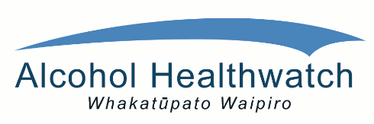

**REGISTRATION:**

**Confirm registration by sending the name(s) and contact details of the person(s) attending before Friday 29th July to:** [**christine@ahw.org.nz**](mailto:christine@ahw.org.nz) **or phone Christine Rogan FASD Project Coordinator 09 5207037 for further information.**

**There is no charge to attend (lunch not included). An HPA grant has enabled a travel subsidy to be offered to families. For application details contact** [**Lee-Tempest@fasd-can.org.nz**](mailto:Lee-Tempest@fasd-can.org.nz)

**WHEN: 9.00am to 5.00pm**

**Saturday 6 August 2016**

**WHERE: Meetings on the Terrace, 152 The Terrace,**

**Wellington City.**

## 

**Alcohol Healthwatch is privileged to once again team up with FASD-CAN to bring parents and caregivers together at another FASD workshop.**

***WITH SPECIAL GUEST SPEAKER***

***David Heaton***

***From Confident Communications.***

# **INVITATION**

*This workshop is an opportunity for families to network, share and support one another with what can often be a challenging and lonely parenting role. When so few in society really understand FASD and what it brings, having good communication skill can be essential. Alongside David Heaton’s inspiring and informative talk will be caregivers walking this path and sharing their wisdom of practice.’*

# **FASD Parents and Caregivers Workshop:**

# **WHEN COMMUNICATION MATTERS**